*CJFAS Article*

**Habitat Heterogeneity and Phenotypic Variation: Site Temperature Largely Predicts Diverse Spawning Portfolios of an Interior Chinook Salmon Stock**

(Author order to be determined).

Russell F. Thurow*1 (ORCID iD: 0000-0002-1362-8599)

Bryan M. Maitland2 (ORCID iD: 0000-0002-4491-5064)

Morgan M. Sparks2 (ORCID iD: 0000-0003-0787-2218)

Daniel J. Isaak2 (ORCID iD: 0000-0003-2963-1546)

John M. Buffington2 (ORCID iD: 0000-0002-2513-5863)

1*US Forest Service, Rocky Mountain Research Station (Emeritus), Salmon, ID, USA 83467*

2*US Forest Service- Rocky Mountain Research Station, 322 East Front St.- Suite 401, Boise, Idaho, USA 83702.*

\**Corresponding author (e-mail:* [*russ.thurow@usda.gov*](mailto:russ.thurow@usda.gov)*)*

**Abstract**

*Note:

-Tables and Figures highlighted

-Supplemental materials highlighted

-Questions or Concerns highlighted

**1. Introduction**

Pacific Salmon populations exhibit extraordinary life history diversity, shaped by complex and heterogeneous environments across their range (Brannon et al. 2004). The enormous diversity of salmon life history traits (Waples et al. 2004) evolved in response to spatiotemporal variation in both biotic and abiotic conditions (Stearns 1976), and acts to reduce risks of demographic failure by buffering populations against environmental change and exploitation (Hilborn et al. 2003, Greene et al. 2009; Schindler et al. 2010; Beamish 2016). Chinook salmon (*Oncorhynchus tshawyscha*) display an especially diverse demographic portfolio characterized by a broad array of phenotypes, including variation in age and timing of seaward migration, duration of freshwater and marine residence, ocean distribution, age and season of spawning migration, and timing of spawning (Healey 1991).

Among these traits, spawning phenology has important ecological and evolutionary consequences. The timing of adult migration and spawning can shape reproductive isolation among temporally segregated groups and lead to fine-scale local adaptation (Manhard et al. 2017). While run timing (entry into freshwater) is often used to define populations segments (Brannon et al. 2004, Waples et al. 2004), here we focus on spawn timing (the date when adults deposit fertilized eggs in gravel), as a fine-scale expression of phenotypic variation. Spawn timing varies within and across salmon populations and has a well-documented genetic component (Ricker 1972; Quinn et al. 2002; Beulke et al. 2023). For example, high site fidelity and limited straying spatially segregates related individuals on spawning grounds and leads to fine-scale genetic structuring (Neville et al. 2006). Spatial heterogeneity in habitat conditions can promote this diversity by selecting for locally adapted phenologies (Ruff et al. 2011).

Temperature strongly influences salmonid spawn timing (Hendenon 1963; Morrison and Smith 1986; Beechie et al. 2008). Because embryonic development rates are mechanistically driven by ambient temperature (Sparks et al. 2025), salmon tend to spawn at times that ultimately synchronize fry emergence with conditions that optimizing offspring growth and development (Quinn 2018; though see Sparks et al. 2019). Several studies have linked site-specific thermal regimes to observed variation in spawning phenology (Sheridan 1962; Burger et al. 1985; Heggberget 1988; Lisi et al. 2013). However, although the importance of temperature as a determinant of spawn timing is well established, underlying landscape features that may driver thermal variation (i.e., physiography, geomorphology, and hydrology), are poorly understood (Montgomery 1999; O’Sullivan et al. 2019). Geomorphic attributes including slope, elevation, confinement, and groundwater connectivity can shape reach-scale thermal regimes, thereby constraining or enabling different spawning strategies (Beechie et al. 2006, 2008; Jonsson and Jonsson 2011). Lisi et al. (2013), for example, demonstrated that variation in watershed slope, elevation, and lake area explained a large proportion of summer stream temperature and sockeye spawn timing in Alaskan streams, highlighting geomorphology’s indirect but powerful role in structuring phenological diversity.

The Middle Fork Salmon River (Middle Fork) supports one of the most intensively monitored Chinook salmon stocks in the Columbia River Basin. Long-term redd surveys by state, federal, and tribal agencies provide a uniquely rich dataset for examining environmental drivers of spawning phenology. The Middle Fork supports wild, indigenous Chinook salmon populations unaltered by direct hatchery supplementation (Thurow et al. 2019), and the watershed is managed as a designated wild anadromous fish sanctuary (IDFG 2019). Minimal anthropogenic effects and a geographic size that facilitates natural processes (i.e., wildfire, floods, debris flows, and snow avalanches) ensure generation and maintenance of diverse environmental conditions (Isaak et al. 2003; Thurow 2015). These natural processes function relatively unimpeded by humans. As a result, natal habitats remain diverse, high quality, and connected, and exotic fishes are relatively uncommon (Thurow 2000; Isaak and Thurow 2006; Thurow 2015).

Here we examine how variation in stream temperature and climatic factors influence Chinook salmon spawn timing across multiple years in several Middle Fork tributaries . Characterizing variation in natural processes within stream networks and understanding how spatial and temporal variability in physical processes and Pacific salmon interact, is critical for establishing recovery targets (Bisson et al. 2009) and for evaluating population persistence under changing environmental conditions (Isaak et al. 2018). Our objectives were to: 1)compile stream reach-scale physical attributes and Chinook salmon spawning phenology from 2002 to 2005, 2) summarize variation in spawn timing across four years in eight streams, and 3) fit a series of linear mixed-effects models to identify associations among environmental covariates and spawn timing.

**2. Methods**

**2.1 Study Area**

The Middle Fork drains ~7,330 km2 of terrain, predominantly within the Frank Church River of No Return Wilderness, and is one of eight original National Wild and Scenic Rivers designated in 1968 (Figure 1; NWSRS 2016). From its headwaters the Middle Fork flows 171 km before joining the Salmon River near Salmon, Idaho (USFS 1998; Minshall et al. 1981; Thurow 2000; Thurow et al. 2019). Approximately 800 km of mainstem and tributary habitat are accessible to Chinook salmon (Mallet 1974; Thurow 1985). Detailed study area information can be found in Minshall et al. (1981), Thurow (2000), Servheen et al. (2001), and Thurow et al. (2019).

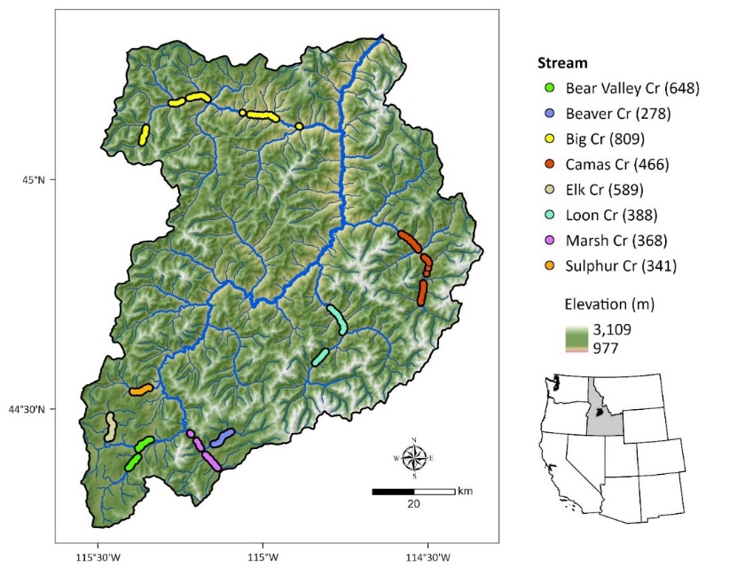

Figure 1. Middle Fork Salmon River watershed illustrating major tributaries and locations of georeferenced Chinook Salmon redds from 2002 to 2005 (count of redds per stream given in parentheses). Point locations were dissolved for visualization.

Adult Chinook salmon migrate from the Pacific Ocean up the Columbia and Snake rivers to spawn in the Middle Fork, typically arriving in early summer and spawning from late July to mid-September. Salmon in this system express a stream-type life history, with most juveniles rearing for one year in freshwater before outmigration (Healey 1991). However, fish exhibit multiple freshwater (age 0-2) and saltwater (0-5) ages, in addition to non-migrating precocial males (Gebhards 1960; James et al. 1998; Copeland and Venditti 2009). Observations suggest that early-arriving adults tend to spawn at higher elevations and later arrivals spawn progressively lower in the basin (Fulton 1968; Gebhards 1959; IDFG 1992; Parkhurst 1950). Although microsatellite analyses fail to confirm this phenotypic variation, new genomic techniques (based on known functions of identified genes) have potential for future analyses (*Helen Neville, personal communication*).

Despite the Middle Fork’s quality, connected habitats that are sustained by natural processes, , Chinook salmon abundance in the system has severely declined. Current populations average 1-3% of salmon numbers that annually returned in the mid-1960s (Thurow et al. 2019). Altered migration corridors are considered the proximate cause of salmon declines in recent decades (Jacobs et al. 2022). Nonetheless, the watershed supports some of the most intact and connected natal habitat remaining in the Columbia River Basin.

**2.2 Reach selection, Chinook salmon redd counts, and spawn timing**

From 2001-2005, we selected study reaches in six major salmon spawning tributaries (Big, Bear Valley, Camas, Loon, Marsh, and Sulphur creeks) to encompass a range of variation in elevation, stream size, and spawn timing. To support collaboration and improve efficiency, some study reaches overlapped with existing index reaches monitored annually by the Idaho Department of Fish and Game (IDFG), the Nez Perce or Shoshone-Bannock tribes, or the U.S. Forest Service (see Thurow et al. 2019 for index reach methods and locations). Spawning occurs across a broad elevation range, from < 920 m in the lower mainstem to > 2000 m in tributary headwaters. After selecting reaches, we designated and marked subsections where redds would be identified.

We intensively monitored Chinook salmon spawning from the onset of redd construction through the completion of spawning. From late July through mid-September, trained observers walked stream banks within each study reach every 3-4 days and searched for newly constructed redds. Observers began surveys before the onset of spawning and georeferenced redd locations with GPS units. To avoid commission errors during the initial survey, observers recorded all prior year redds or redd-like streambed features that might have been confused with new redds.

Based on our prior observations in the Salmon River basin, female Chinook salmon typically remain on excavated redds for 3-5 days. Consequently, we assumed our 3-5 day survey interval maximized the likelihood of detecting all redds soon after their construction. All surveys were conducted between 0930 and 1700 to maximize visibility, and observers wore polarized sunglasses.

Considering our surveys were completed every 3-4 days, we inferred spawn timing from the first date a redd was recorded as fully constructed. Redd locations were spatially joined to stream reaches in the NHDPlus dataset (Moore et al. 2019) and assigned a common identifier (COMID). This identifier was used to link each redd with environmental covariates from the corresponding stream reach (i.e., COMID). (Marsh Creek tributaries) because ofThe final dataset contained 3,016 georeferenced redds (*i.e.*, inferred spawn date) across 108stream reaches (i.e., COMIDs), nested within six major spawning tributaries that also included Beaver Creek (tributary to Marsh Creek) and Elk Creek (tributary to Bear Valley Creek) to total eight different spawning streams, and spanning four years.

**2.3 Covariates**

To identify environmental predictors of spawn timing, we linked each redd location to stream temperature, discharge, elevation, and slope at the stream reach scale (COMID). Covariates were selected based on ecological relevance, full coverage across the study area, and low collinearity. Elevation and slope were obtained from NHDPlus (Moore et al. 2019). We indexed thermal conditions using modeled daily stream temperatures from Siegel et al. (2023), and confirmed strong agreement with temperature logger data recorded in Idaho (R2 > 0.90; Supplement Table or Figure?). Stream discharge data were drawn from a single USGS gage (13309220) near the basin outlet. For each redd, we calculated sequential time-windowed summaries of temperature and flow (e.g., 30-, 60-, and 90-day averages prior to, during, and following the inferred spawn date).

Initially, we established the appropriate modeling framework, using exploratory data analysis and visualizations to evaluate variation in spawn timing across years and streams, examine bivariate relationships between spawn date and continuous covariates, and assess pairwise correlations among predictors (Appendix S1, Section XX). Based on these results, we retained only 90-day antecedent temperature (`temp_90`) as a focal thermal covariate; post-spawn and fixed-date summaries were more weakly associated with spawn timing and showed higher collinearity. A clear nonlinear relationship emerged between `temp_90` and spawn date, with quadratic temperature terms consistently improving model fit over linear specifications. Adding stream and year as fixed effects further improved model performance, indicating spatial and interannual variation in phenology. Elevation exhibited a weak association with spawn timing and was retained for its ecological interpretability, while slope was uncorrelated but provisionally included. Although 90-day antecedent streamflow was initially considered, we excluded it because of its poor spatial resolution, strong collinearity with year, and limited ecological relevance at the reach scale. Full covariate descriptions and exploratory results are provided in Appendix XX.

**2.4 Data analysis**

We used linear mixed-effects models to evaluate environmental predictors of Chinook salmon spawn timing, with redd observation day-of-year (yday) as the response variable. Continuous covariates were scaled (mean = 0, SD = 1) to aid convergence and interpretation. All models included a random intercept for `COMID` to account for repeated measures across stream reaches. Further, based on exploratory analysis and biological expectations of nonlinear thermal responses, temperature effects were modeled using both linear and quadratic terms for the 90-day average stream temperature prior to spawning.

We fit 31 additive models representing all combinations of fixed effects (temp_90, stream, year, slope, and mean_elevation). Candidate models were fit using maximum likelihood to allow direct comparison across differing fixed-effect structures. We also tested whether model performance improved by allowing the effect of temperature to vary across stream reaches via adding a random slope for temp_90 to the COMID grouping factor. This random slope model was fit with restricted maximum likelihood (REML) and compared to the simpler random intercept model. To determine whether the quadratic 90-day antecedent temperature term remained necessary with random slopes, we re-fit the model with and without the quadratic effect using maximum likelihood. Finally, we evaluated whether additional fixed-effect interactions improved model performance by adding interaction terms between 90-day antecedent temperature and either stream or year.

**3. Results**

**3.1 Spawn timing variation in space and time**

Across all streams and years, Chinook salmon spawning exhibited a broadly unimodal distribution, with most activity concentrated between mid-August and early September (Figure 2A). The global mean spawn date was day 240 (August 28th), although year-specific means varied by nearly three weeks (Figure 2A). Stream-level spawning distributions revealed additional spatial structure (Figure 2B), with some streams (e.g., Bear Valley and Beaver creeks) exhibiting narrower peaks, while others (e.g., Big and Camas creeks) displayed broader or later distributions. Year effects were also evident (Figure 2C), with 2005 skewed later than preceding years.

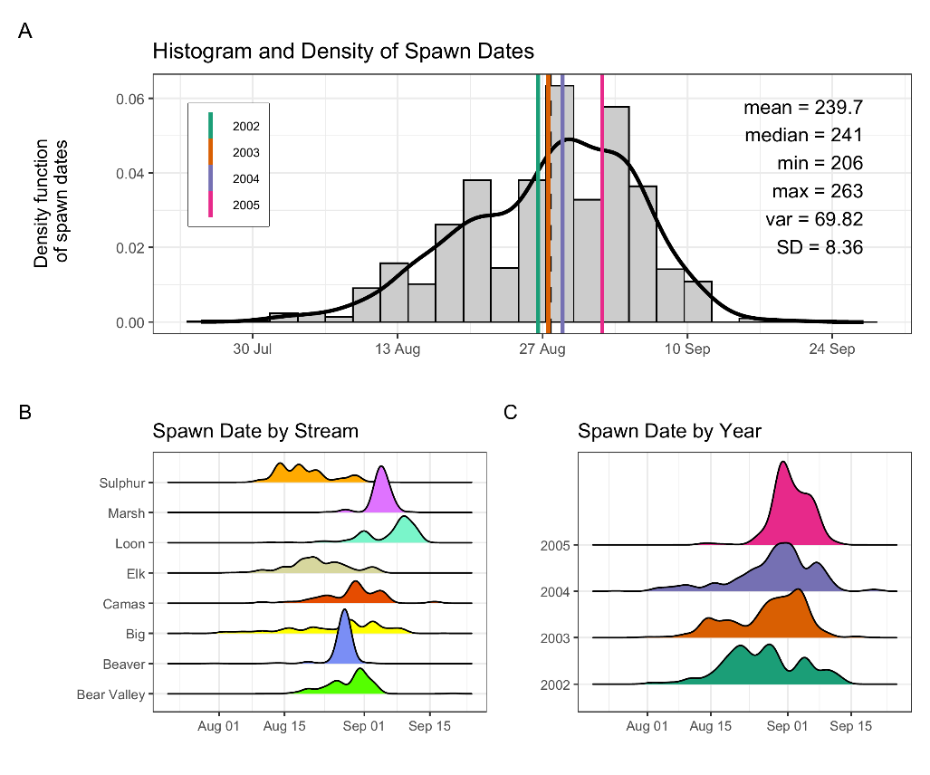

Figure 2: Histogram and density of Chinook salmon spawn timing across all streams and years (A), by stream (B), and by year (C). In panel (A), the histogram and kernel density illustrate the overall distribution of spawn dates; vertical-colored lines illustrate year-specific means, and the black line depicts the global mean. Spawn timing was generally unimodal, peaking in late August to early September.

When examined jointly by stream and year, density curves illustrated that each stream expressed a characteristic spawn timing “signature”, although the strength and consistency of this signature varied (Appendix S1, Figure XX-XX, variation by stream, year, and COMID). Some streams (e.g., Beaver and Marsh creeks) displayed sharp, highly synchronous peaks, whereas others (e.g., Big, Camas, and Elk creeks) exhibited broader, more heterogeneous distributions. These stream-level differences were nested within year effects, reinforcing the combined influence of space and time on diverse spawning phenology.

The cumulative proportion of redds (Figure 3) provided an intuitive view of the pace and duration of spawning. Streams such as Marsh and Sulphur creeks exhibited rapid increases, suggesting short, concentrated spawning intervals. In contrast, Big and Camas creeks illustrated more gradual redd accumulations, indicative of extended spawning seasons. Interannual variability was also evident, with some streams shifting substantially across years. Together, these patterns highlight the pronounced spatial and temporal heterogeneity in Chinook salmon spawn timing across the Middle Fork watershed.

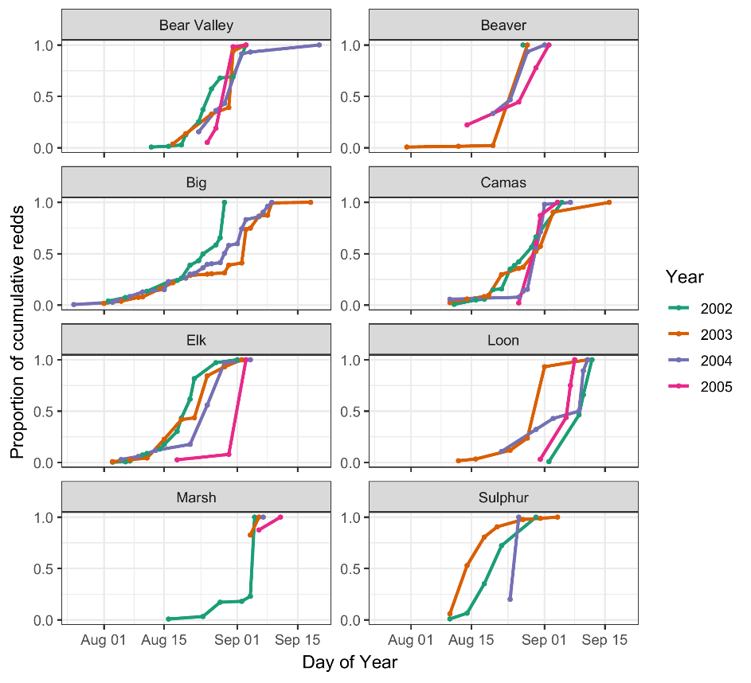

Figure 3. Proportion of cumulative Chinook salmon redds over time (day of year) across years (2002–2005) and streams. Each line represents a different year, with color denoting the year. Stream-specific panels illustrate temporal variation in the progression of spawning activity, as measured by cumulative redd counts normalized to the maximum value in each stream-year combination.

**3.2 Model comparison**

Model comparisons identified stream identity, interannual variation, and nonlinear temperature responses as the strongest predictors of Chinook salmon spawn timing, while topographic variables contributed less consistently (Table 1).

Table 1. AIC selection performance metrics for additive linear models; top 10 of 31 shown.

|  |  |  |  |  |  |  |  |
| --- | --- | --- | --- | --- | --- | --- | --- |
| Model | df | AIC | delta_AIC | R2_marginal | R2_conditional | RMSE | ICC |
| m26 | 16 | 13356.04 | 0 | 0.785 | 0.956 | 2.023 | 0.796 |
| m31 | 17 | 13358.04 | 1.998 | 0.785 | 0.956 | 2.023 | 0.795 |
| m27 | 16 | 13468.96 | 112.925 | 0.737 | 0.979 | 2.022 | 0.922 |
| m16 | 15 | 13473.12 | 117.079 | 0.729 | 0.98 | 2.022 | 0.926 |
| m29 | 10 | 13487.82 | 131.783 | 0.727 | 0.984 | 2.022 | 0.942 |
| m19 | 9 | 13488.73 | 132.69 | 0.726 | 0.984 | 2.022 | 0.943 |
| m7 | 8 | 13531.17 | 175.128 | 0.66 | 0.987 | 2.022 | 0.962 |
| m20 | 9 | 13532.9 | 176.858 | 0.66 | 0.987 | 2.022 | 0.962 |
| m17 | 13 | 15787.25 | 2431.21 | 0.783 | 0.88 | 3.112 | 0.446 |

Model m26 had the lowest AIC among the candidate models, yet predicted later spawning at higher elevations which is counter to raw data patterns and observations confirming earlier spawning in cooler, high-elevation reaches. Therefore, we did not retain m26 despite its statistical support. Model m31 (added slope to m26) performed nearly identically (ΔAIC = 2) and retained the same inaccurate elevation effect, leading us to exclude it as well. Model m27 (replaced mean_elevation with slope) performed substantially worse (ΔAIC > 110, lower marginal R²), indicating that elevation, not slope, was the topographic driver of likelihood gains. Together, these results suggest that topographic terms improved model likelihood but introduced biologically implausible effects, likely a result of collinearity with temperature and confounded with stream identity (Appendix X, Figures XX). We therefore selected model m16 (temp_90 + quadratic term + stream + year) as the most interpretable and parsimonious model. Model m16 had nearly identical predictive accuracy (RMSE = 2.02) and conditional R² (0.980) compared to m26, despite a modest reduction in marginal R² (0.729 vs. 0.785). We used this model as the base structure for our subsequent evaluation of random slopes and interaction terms.

To account for site-level variation in thermal sensitivity, we extended the additive base model by adding COMID-specific random slopes for temperature. This substantially improved model fit (ΔAIC = 510), reduced prediction error (RMSE = 1.78 days), and slightly increased conditional R², indicating that temperature effects vary meaningfully among stream reaches and are better represented as random slopes (Appendix X, Table XX).

|  |  |  |  |  |  |  |  |
| --- | --- | --- | --- | --- | --- | --- | --- |
| Model | df | AIC | delta_AIC | R2_marginal | R2_conditional | RMSE | ICC |
| m16_rs | 17 | 12948.763 | 0 | 0.698 | 0.985 | 1.781 | 0.949 |
| m16 | 15 | 13459.046 | 510.283 | 0.714 | 0.981 | 2.022 | 0.932 |

We next evaluated whether the quadratic temperature term remained necessary in the presence of random slopes. The model including both random slopes and a quadratic temperature effect outperformed the linear version (ΔAIC = 20.4), suggesting that both components contributed complementary information (Appendix X, Table XX).

|  |  |  |  |  |  |  |  |
| --- | --- | --- | --- | --- | --- | --- | --- |
| Model | df | AIC | delta_AIC | R2_marginal | R2_conditional | RMSE | ICC |
| m16_rs | 17 | 12965.969 | 0 | 0.713 | 0.984 | 1.782 | 0.945 |
| m16_rs_noquad | 16 | 12986.41 | 20.441 | 0.714 | 0.984 | 1.788 | 0.943 |

Finally, we assessed whether interactions between temperature and either stream or year provided additional explanatory power. Although the model including temp_90 × year exhibited a large AIC improvement, it predicted an implausible, inverted quadratic response, suggesting overfitting or confounding. The model with temp_90 × stream produced more reasonable predictions yet offered minimal improvement, and most interaction terms were non-significant. These results confirm that the random slope structure already accounts for much of the variation captured by fixed-effect interactions (Appendix X, Table XX).

|  |  |  |  |  |  |  |  |
| --- | --- | --- | --- | --- | --- | --- | --- |
| Model | df | AIC | delta_AIC | R2_marginal | R2_conditional | RMSE | ICC |
| m202 | 20 | 11568.629 | 0 | 0.62 | 0.994 | 1.359 | 0.985 |
| m201 | 24 | 12948.514 | 1379.886 | 0.736 | 0.985 | 1.786 | 0.944 |
| m16_rs | 17 | 12965.969 | 1397.34 | 0.713 | 0.984 | 1.782 | 0.945 |

These results led us to retain the random slope model, without interactions, as our final model (m16_rs), which we refit with REML for interpretation. This model balances explanatory power, biological realism, and parsimony: it captures general patterns in spawn timing via fixed effects, and accommodates local deviations in thermal sensitivity via random slopes. Consequently, this model structure formed the basis for subsequent diagnostics, predictions, and ecological interpretation.

**3.3 Final model fit and diagnostics**

Model fit for the final model (`m16_rs`) was strong: marginal R² (fixed effects only) was 0.698, while conditional R² (fixed + random effects) was 0.985 (Table 2), indicating that most explanatory power came from spatially varying temperature responses. Combined with high ICC (0.95), these diagnostics and confirm that the final model effectively captured both broad-scale structure and stream-level heterogeneity in spawn timing.

Table 2. Parameter estimates from the final model. CI represents the 95% confidence interval.

|  |  |  |  |
| --- | --- | --- | --- |
|  | m16_rs | | |
| *Predictors* | *Estimates* | *CI* | *p* |
| (Intercept) | 235.09 | 230.95 – 239.22 | **<0.001** |
| temp 90 | 13.9 | 13.06 – 14.74 | **<0.001** |
| temp 90^2 | -0.85 | -1.15 – -0.55 | **<0.001** |
| stream [Beaver] | 17.41 | 10.62 – 24.19 | **<0.001** |
| stream [Big] | -0.19 | -5.37 – 5.00 | 0.944 |
| stream [Camas] | 2.3 | -3.08 – 7.69 | 0.402 |
| stream [Elk] | 11.97 | 4.88 – 19.06 | **0.001** |
| stream [Loon] | 2.8 | -2.47 – 8.06 | 0.298 |
| stream [Marsh] | 7.93 | 2.30 – 13.56 | **0.006** |
| stream [Sulphur] | 14.69 | 8.69 – 20.69 | **<0.001** |
| year [2003] | -5 | -5.23 – -4.77 | **<0.001** |
| year [2004] | 2.77 | 2.53 – 3.01 | **<0.001** |
| year [2005] | 3.68 | 3.38 – 3.98 | **<0.001** |
| **Random Effects** | | | |
| σ2 | 3.36 | | |
| τ00 COMID | 49.73 | | |
| τ11 COMID.temp_90 | 12.63 | | |
| ρ01 COMID | -0.23 | | |
| ICC | 0.95 | | |
| N COMID | 104 | | |
| Observations | 3016 | | |
| Marginal R2 / Conditional R2 | 0.698 / 0.985 | | |

Model diagnostics indicated strong performance and no violations of key assumptions (Appendix X, Table XX). The posterior predictive check showed excellent agreement between observed and predicted spawn timing, with overlapping distributions and no major deviations. Model predictions closely matched observed spawn timing, with predicted values aligning well along the 1:1 line. Residual plots revealed acceptable linearity and homoscedasticity: although the residuals vs. fitted values showed a slight trend and some funneling at lower fitted values, these patterns were minor and likely reflect skew in early spawn dates rather than model misspecification.

The normal Q-Q plot indicated slight right-skew and heavier-than-normal tails, but residuals were generally well-behaved. Random effect Q-Q plots for both intercepts and slopes were similarly close to normal. A small number of data points exceeded standard influence thresholds (|standardized residual| > 2, moderate leverage), but none were extreme enough to justify removal, and their influence was limited. Variance inflation factors (VIFs) for all fixed effects were below 2, suggesting low collinearity.

**3.4 Population-level effects**

We estimated marginal mean of `yday` at each factor level, averaging over the random effects, to provide an overall estimate of the effect in the population (Figure 4).

Figure 4. Predicted mean spawn dates by stream (A), year (B) and stream and year (C), from the final mixed-effects model. Black points with black lines (A, B), and colored points with horizontal lines (C) represent estimated marginal means and 95% confidence intervals. Boxplots in panels A and B depict the distribution of observed redd counts by stream and year, respectively, with individual data points in grey. The modeled predictions represent marginal means accounting for fixed effects and averaged over random effects.

We observed significant differences in spawn timing between many stream pairs (Figure 4; Table S?), particularly in Loon Creek (later spawning) compared to Sulphur Creek (earlier spawning). For example, fish in Loon Creek spawned significantly later than in Bear Valley, Camas, or Elk Creek, while Sulphur Creek exhibited significantly earlier spawn timing than all other streams except Elk Creek. These patterns reflect spatial heterogeneity in temperature and elevation across streams, that are not fully captured by fixed effects alone.

There was a clear trend toward later spawning over the four-year period (Figure 4; Table S?). Spawning in 2005 occurred significantly later than in all previous years. Although differences between 2002 and 2003 were not statistically significant, later years (2004 and especially 2005) were associated with progressively later mean spawn timing. This temporal shift likely reflects interannual variability in temperature and flow conditions.

Stream-specific predictions show a consistent pattern: spawn timing increases nonlinearly with 90-day mean stream temperature, leveling off at high temperatures (Figure 5). This plateau is consistent with biological expectations, as spawning may be constrained by environmental or physiological thresholds. Stream-to-stream variation in predicted timing reflects both fixed stream effects and COMID-specific random intercepts and slopes. Year-specific predictions similarly show consistent thermal responses across years, with modest offsets in average spawn timing due to year effects.

Figure 5. Predicted relationship between spawn timing and 90-day pre-spawn mean temperature by stream and year. Lines represent model predictions from the final mixed-effects model. Colored points illustrate observed spawn timing, shaded ribbons represent 95% confidence intervals for predictions.

**3.5 Group-level effects (stream-reach / COMID deviations from fixed / population effects)**

Random intercepts and slopes varied considerably among COMIDs, reflecting spatial heterogeneity in both average spawn timing and thermal sensitivity (Figure 6A). We found considerable spread in intercepts, reflecting variability in average spawn timing between reaches. The random slopes for `temp_90` likewise varied meaningfully across COMIDs, indicating that temperature–spawn timing relationships are not constant across space. Sites with earlier average spawn timing (lower intercepts) generally exhibited stronger positive responses to temperature (higher slopes), while later-spawning sites tended to present weaker temperature effects, a pattern also evident in the weak negative correlation between intercepts and slopes (r = -0.2; Figure 6B). This indicates that reaches with earlier average spawn timing (i.e., negative intercepts) tend to exhibit stronger temperature sensitivity (i.e., steeper positive slopes), whereas later-spawning reaches present weaker responses to temperature. These findings highlight spatial heterogeneity in phenological flexibility, with potential implications for how different Middle Fork salmon populations may respond to climate change.

Figure 6: (A) COMID-specific random parameter estimates for intercepts (left) and slopes (right). Points represent best linear unbiased predictions (BLUPs) from the final model, with horizontal bars indicating ±1.96 standard errors. (B) Correlation between random intercepts and slopes for 90-day temperature across COMIDs. Each point represents a stream reach (COMID).

When grouped by stream, Bear Valley and Big creeks exhibited early average spawn timing and high thermal sensitivity, while Sulphur and Marsh creeks had later average timing with flatter temperature responses (Figure 7). WHAT ??

Figure 7. Boxplots of random intercepts and slopes for 90-day pre-spawn temperature by stream. Each box represents the distribution of best linear unbiased predictions (BLUPs) for a COMID's random intercept (average spawn timing) or slope (thermal sensitivity).

However, when examining individual random effects for each COMID and stream, we observed considerable variation in both intercepts and slopes among streams (Figure 6, 7; Figure S21). For example, Bear Valley, Big, Loon, and Camas creeks had some of the earliest average spawn timings, yet also exhibited a wide range of thermal sensitivities. In contrast, Sulphur Creek had later average spawn timing but also exhibited considerable variability in its response to temperature. While the overall relationship is positive and nonlinear, individual COMID slopes and intercepts vary considerably. Some reaches displayed steeper increases in spawn timing with temperature (i.e., stronger thermal sensitivity), while others were relatively flat, indicating a muted or more buffered response. Grouping by stream illustrated that some streams (e.g., Bear Valley and Marsh creeks) exhibit tightly clustered trajectories, while others (e.g., Big, Camas, and Loon creeks) were more divergent. This variation likely reflects fine-scale differences in local hydrology, geomorphology, or biological factors that influence how fish respond to thermal cues within different Middle Fork spawning streams. The consistency of the overall trend, despite local heterogeneity, supports the biological relevance of temperature in structuring spawn timing.

Figure S2. Random intercepts and slopes for 90-day pre-spawn temperature by stream. Each bar represents the best linear unbiased prediction (BLUP) for a COMID's random intercept (average spawn timing) or slope (thermal sensitivity). Bars are colored by stream.

. Predicted spawn timing by 90-day pre-spawn temperature and COMID. Each line represents the predicted spawn timing for a specific COMID, colored by stream. The black line and shaded ribbon represent the 95% confidence interval for population-level predictions.

**3.6 Elevation effects embedded in random structure**

Although mean elevation was excluded as a fixed effect with temperature and inconsistent global directionality, examination of random effects against elevation revealed spatial structure that elevation helped explain (Figure 10). Random intercepts (average spawn timing) showed positive relationships with elevation in some streams (e.g., Big Creek), where higher-elevation sites tended to have later average spawning relative to the population mean. In contrast, other streams (e.g., Bear Valley, Beaver) showed little or no elevation pattern.

Random slopes (thermal sensitivity to temperature) exhibited similarly idiosyncratic patterns. In some cases (e.g., Camas, Marsh), thermal sensitivity declined with elevation, suggesting that fish at higher elevations may respond less strongly to interannual temperature variability. In others, relationships were weak or even opposite in direction.

Taken together, these patterns indicate that elevation influences both average spawn timing and thermal sensitivity, but in ways that differ across streams. This heterogeneity justifies our decision to capture elevation-linked variation through COMID-level random effects rather than imposing a single fixed elevation term.



Relationships between mean elevation and random effects from the final model (m16_rs). Panels A and C show random intercepts (average spawn timing) plotted against elevation for tributaries above 1800 m elevation (A) and below 1800 m elevation (C). Panels B and D show random slopes (thermal sensitivity) plotted against elevation for the same sets of streams. Points represent COMID-level estimates, with fitted lines shown for each stream. Elevation was excluded as a fixed effect due to collinearity with temperature and inconsistent global directionality, but these plots illustrate that elevation is associated with both average spawn timing and thermal sensitivity in stream-specific ways. This supports modeling elevation-linked variation through COMID-level random effects rather than a single global fixed effect.